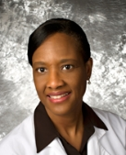 | Charlene Blache, MD, FAAP  Dr. Blache is a board-certified Pediatrician in practice since 1999. Originally from Trinidad and Tobago in the eastern Caribbean, she graduated from the University of the West Indies in 1992 with honors in Community Health. Dr. Blache moved to the United States in 1995 and in 1998 completed her Pediatric Residency Training at Brooklyn Hospital Center in New York. In 1999 she moved to South Georgia to practice in Brooks County and in 2005 she proudly opened the doors of Southern Pediatric Clinic.
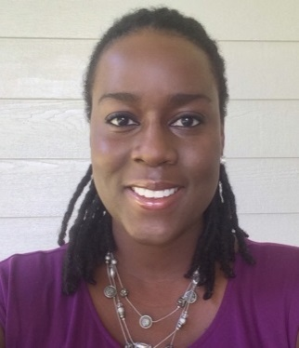 | Kereese Gayle-Farias, MD  Dr. Gayle-Farias is originally from Jamaica in the Caribbean. She graduated from the Latin American School of Medicine in Havana, Cuba and is fluent in Spanish. She completed her Pediatric Residency Training at the Children’s Hospital of New Jersey in Newark in 2015. She and her husband moved to South Georgia to be closer to family while also looking to be of service to a tight-knit community. She loves working with children of all ages and is looking forward to working with your family!
Virginia Cochran  Certified Pediatric Nurse Practitioner  Virginia received her specialized pediatric nurse practitioner degree from Emory University. Before relocating to Valdosta in 2004, Virginia spent two years working as a pediatric nurse practitioner in Atlanta. Virginia loves working with children and looks forward to meeting and working with yours soon! |  | Nalitia Zow  Certified Family Nurse Practitioner  Nalitia was born in St. Mary’s, GA and raised in Folkston, GA. She began serving the Pediatric population in Tifton, GA after becoming a family nurse practitioner in 2015. She joined Southern Pediatric Clinic in January 2017 and looks forward to meeting and caring for your child(ren).

